Computer Graphics

Practical file

**Submitted by,**Divya A.   
College Roll No: 20201457  
Exam Roll No: 20016570005  
BSc (Hons) Computer Science

Ramanujan College

**Submitted to,**Mr. Arun Agarwal

Assistant Professor  
Dept. of Computer Science

Ramanujan College

University of Delhi

**TABLE OF CONTENTS**

|  |  |  |
| --- | --- | --- |
| **SL. NO** | **CONTENT** | **PAGE NO** |
| **1.** | **Write a program to implement Bresenham’s line drawing algorithm.** | **2-4** |
| **2.** | **Write a program to implement mid-point circle drawing algorithm.** | **4-7** |
| **3.** | **Write a program to clip a line using Cohen and Sutherland line clipping algorithm.** | **7-13** |
| **4.** | **Write a program to clip a polygon using Sutherland Hodgeman algorithm.** | **13-20** |
| **5.** | **Write a program to fill a polygon using Scan line fill algorithm.** | **20-26** |
| **6.** | **Write a program to apply various 2D transformations on a 2D object (use homogenous Coordinates).** | **27-35** |
| **7.** | **Write a program to apply various 3D transformations on a 3D object and then apply parallel and perspective projection on it.** | **35-48** |
| **8.** | **Write a program to draw Hermite /Bezier curve.** | **49-53** |

1. **Write a program to implement Bresenham’s line drawing algorithm.**

#include<bits/stdc++.h>

#include<graphics.h>

using namespace std;

//Function to implement Bresenham's line drawing algorithm

void bresline(int x1,int y1,int x2,int y2)

{

int dx,dy,P,x,y;

int xmid=getmaxx()/2;

int ymid=getmaxy()/2;

dx=x2-x1; dy=y2-y1;

x=x1; y=y1;

P=2*dy-dx;

while(x<=x2)

{

if(P>=0)

{

putpixel(x,y,YELLOW);

y=y+1;

P=P+2*dy-2*dx;

}

else

{

putpixel(x,y,YELLOW);

P=P+2*dy;}

x=x+1;

}

}

int main()

{

int gdriver = DETECT,gmode;

initgraph(&gdriver,&gmode,"C:\\Dev-Cpp\\lib");

setbkcolor(BLACK); cleardevice();

int x1,x2,y1,y2;

cout<<" Bresenham's Line Drawing Algorithm \n\n";

cout<<" Enter the x co-ordinate of point 1: ";

cin>>x1;

cout<<"\n Enter the y co-ordinate of point 1: ";

cin>>y1;

cout<<"\n Enter the x co-ordinate of point 2: ";

cin>>x2;

cout<<"\nEnter the y co-ordinate of point 2: ";

cin>>y2;

cleardevice();

int xmid = getmaxx()/2;

int ymid = getmaxy()/2;

line(xmid , 0 , xmid , getmaxy());

line(0 , ymid , getmaxx() , ymid);

bresline(x1+xmid,ymid-y1,x2+xmid,ymid-y2);

getch();

closegraph();

return 0;

}

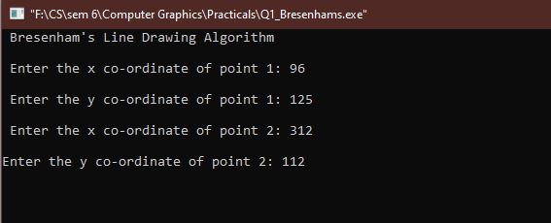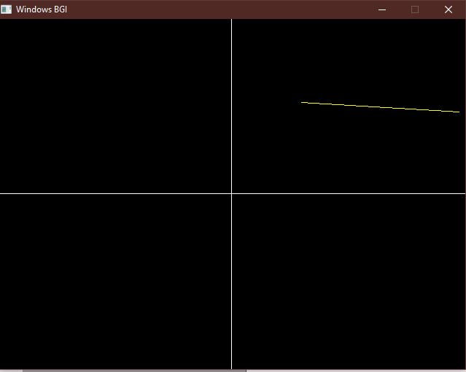

1. **Write a program to implement mid-point circle drawing algorithm.**

#include<iostream>

#include<graphics.h>

#include<math.h>

using namespace std;

void circlePlotPoints (int, int, int, int);

int xmid, ymid;

void circleMidpoint(int xCenter, int yCenter, int radius)

{

int x = 0;

int y = radius;

int p = 1 - radius;

//circlePlotPoints (x, y, xCenter, yCenter);

while (x <= y)

{

circlePlotPoints (x, y, xCenter, yCenter);

if (p < 0)

{

p += (2*x)+1;

}

else

{

p +=(2*(x-y))+1;

y--;

}

x++ ;

}

}

void circlePlotPoints(int x, int y, int xCenter, int yCenter){

putpixel (xCenter + x, yCenter + y, YELLOW);

putpixel (xCenter - x, yCenter + y, YELLOW);

putpixel (xCenter + x, yCenter - y, YELLOW);

putpixel (xCenter - x, yCenter - y, YELLOW);

putpixel (xCenter + y, yCenter + x, YELLOW);putpixel (xCenter - y, yCenter + x, YELLOW);

putpixel (xCenter + y, yCenter - x, YELLOW);

putpixel (xCenter - y, yCenter - x, YELLOW);

}

int main()

{

int x , y;

float r;

int gd = DETECT , gm;

initgraph(&gd, &gm, (char*)"");

cout<<" Mid-point Circle Algorithm \n\n";

cout<<" Enter the x co-ordinate of centre : ";

cin>>x;

cout<<"\n Enter the y co-ordinate of centre : ";

cin>>y;

cout<<"\n Enter the radius : ";

cin>>r;

xmid = getmaxx()/2;

ymid = getmaxy()/2;line(xmid , 0 , xmid , getmaxy());

line(0 , ymid , getmaxx() , ymid);

circleMidpoint(x + xmid , ymid - y , r);

getch();

closegraph();

return 0;

}

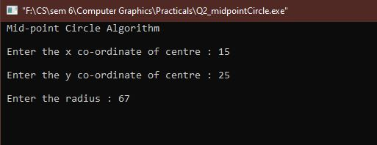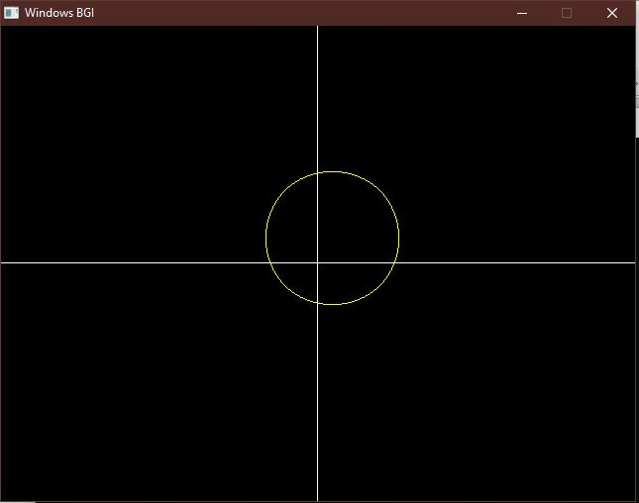

1. **Write a program to clip a line using Cohen and Sutherland line clipping algorithm.**

#include <iostream>

#include<graphics.h>

#include<math.h>

using namespace std;

float x_mid, y_mid;

// Defining region codes

const int TOP = 1; // 0001

const int BOTTOM = 2; // 0010

const int RIGHT = 4; // 0100

const int LEFT = 8; // 1000

// Defining x_max, y_max and x_min, y_min for clipping rectangle.

const int x_max = 300;

const int y_max = 300;

const int x_min = 80;

const int y_min = 80;

// Function to compute region code for a point(x, y).

int ComputeOutCode(double x, double y)

{

// Point initialized as being inside the clipping window.

int code = 0;

if (y > y_max)

code |= TOP;

else if (y < y_min)

code |= BOTTOM;

if (x > x_max)

code |= RIGHT;

else if (x < x_min)

code |= LEFT;

return code;

}

// Implementing Cohen-Sutherland algorithm.

void CohenSutherlandLineClipAndDraw(double x1, double y1, double x2,

double y2)

{

// Initialize line as outside the clipping window.

bool accept = false, done = false;

// Compute region codes for P1, P2.

int code1 = ComputeOutCode(x1, y1);

int code2 = ComputeOutCode(x2, y2);

do

{

if (!(code1 | code2))

{

// Trivial accept and exit.

accept = true;

done = true;

break;

}

else if (code1 & code2)

{

// If both endpoints are outside clipping window, so trivial reject.

break;

}

else

{

/* Failed both tests, so calculate the line segment to clip:

from an outside point to an intersection with clip edge.

*/

double x, y;

int code_out;

// At least one endpoint is outside the clip rectangle, pick it.

code_out =(code1 != 0)? code1 : code2;

// Now, find intersection point.

// Using formulas: y = y1 + slope * (x - x1), x = x1 + (1 / slope) * (y - y1).

if (code_out & TOP){

// Point is above the clipping window.

x = x1 + (x2 - x1) * (y_max - y1) / (y2 - y1);

y = y_max;

}

else if (code_out & BOTTOM)

{

// Point is below the clipping window.

x = x1 + (x2 - x1) * (y_min - y1) / (y2 - y1);

y = y_min;

}

else if (code_out & RIGHT)

{

// Point is to the right of clipping window.

y = y1 + (y2 - y1) * (x_max - x1) / (x2 - x1);

x = x_max;

}

else if (code_out & LEFT)

{

// Point is to the left of clipping window.

y = y1 + (y2 - y1) * (x_min - x1) / (x2 - x1);

x = x_min;

}

// Now we move outside point to intersection point to clip.

if (code_out == code1){

x1 = x;

y1 = y;

code1 = ComputeOutCode(x1, y1);

}

else

{

x2 = x;

y2 = y;

code2 = ComputeOutCode(x2, y2);

}

}

}

while(done == false);

if (accept)

{

// Drawing the clipped line.

cout << "Line accepted from (" << x1 << ", " << y1 << ") to (" << x2

<< ", " << y2 << ")" << endl;

setcolor(RED);

line(x1, y1, x2, y2);

}

else

cout << "Line rejected" << endl;

}

// Driver code

int main(){

int gd = DETECT, gm;

initgraph(&gd, &gm, (char*)"");

float X = getmaxx(), Y = getmaxy();

float x_mid = X / 2;

float y_mid = Y / 2;

setcolor(WHITE);

outtextxy(30, 30, "Cohen-Sutherland Line Clipping Algorithm");

// Drawing Window using Lines

setcolor(YELLOW);

line(x_min, y_min, x_max, y_min);

line(x_max, y_min, x_max, y_max);

line(x_max, y_max, x_min, y_max);

line(x_min, y_max, x_min, y_min);

setcolor(GREEN);

// First Line segment

// P1 = (250, 320), P2 = (330, 270)

line(250, 320, 330, 270);

CohenSutherlandLineClipAndDraw(250, 320, 330, 270);

// Second Line segment

// P1 = (80, 80), P2 = (150, 150)

CohenSutherlandLineClipAndDraw(100, 100, 150, 150);

// Third Line segment

// P1 = (290, 310), P2 = (320, 500)

setcolor(GREEN);

line(290, 310, 300, 400);

CohenSutherlandLineClipAndDraw(290, 310, 320, 400);

// Fourth Line segment

// P1 = (450, 450), P2 = (500, 500)

setcolor(GREEN);

line(350, 150, 450, 250);

CohenSutherlandLineClipAndDraw(350, 150, 450, 250);

getch();

closegraph();

return 0;

}

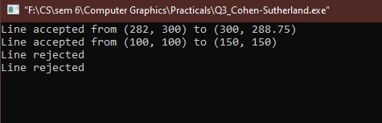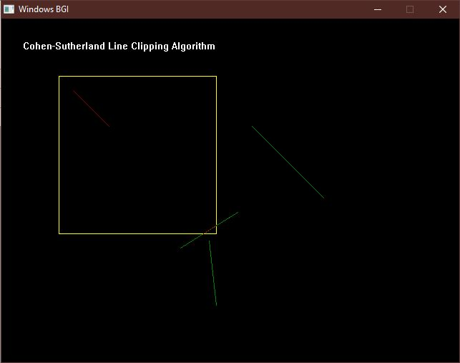

1. **Write a program to clip a polygon using Sutherland Hodgeman algorithm.**

#include<iostream>

#include<conio.h>

#include<graphics.h>

using namespace std;

#define round(a) ((int)(a+0.5))

int k;

float xmin,ymin,xmax,ymax,arr[20],m;

void clipl(float x1,float y1,float x2,float y2){

if(x2-x1)

m=(y2-y1)/(x2-x1);

else

m=100000;

if(x1 >= xmin && x2 >= xmin)

{

arr[k]=x2;

arr[k+1]=y2;

k+=2;

}

if(x1 < xmin && x2 >= xmin)

{

arr[k]=xmin;

arr[k+1]=y1+m*(xmin-x1);

arr[k+2]=x2;

arr[k+3]=y2;

k+=4;

}

if(x1 >= xmin && x2 < xmin)

{

arr[k]=xmin;

arr[k+1]=y1+m*(xmin-x1);

k+=2;

}

}

void clipt(float x1,float y1,float x2,float y2)

{

if(y2-y1)

m=(x2-x1)/(y2-y1);

else

m=100000;

if(y1 <= ymax && y2 <= ymax)

{

arr[k]=x2;

arr[k+1]=y2;

k+=2;

}

if(y1 > ymax && y2 <= ymax)

{

arr[k]=x1+m*(ymax-y1);

arr[k+1]=ymax;

arr[k+2]=x2;

arr[k+3]=y2;

k+=4;

}

if(y1 <= ymax && y2 > ymax)

{

arr[k]=x1+m*(ymax-y1);

arr[k+1]=ymax;

k+=2;}

}

void clipr(float x1,float y1,float x2,float y2)

{

if(x2-x1)

m=(y2-y1)/(x2-x1);

else

m=100000;

if(x1 <= xmax && x2 <= xmax)

{

arr[k]=x2;

arr[k+1]=y2;

k+=2;

}

if(x1 > xmax && x2 <= xmax)

{

arr[k]=xmax;

arr[k+1]=y1+m*(xmax-x1);

arr[k+2]=x2;

arr[k+3]=y2;

k+=4;

}

if(x1 <= xmax && x2 > xmax)

{

arr[k]=xmax;arr[k+1]=y1+m*(xmax-x1);

k+=2;

}

}

void clipb(float x1,float y1,float x2,float y2)

{

if(y2-y1)

m=(x2-x1)/(y2-y1);

else

m=100000;

if(y1 >= ymin && y2 >= ymin)

{

arr[k]=x2;

arr[k+1]=y2;

k+=2;

}

if(y1 < ymin && y2 >= ymin)

{

arr[k]=x1+m*(ymin-y1);

arr[k+1]=ymin;

arr[k+2]=x2;

arr[k+3]=y2;

k+=4;

}

if(y1 >= ymin && y2 < ymin){

arr[k]=x1+m*(ymin-y1);

arr[k+1]=ymin;

k+=2;

}

}

int main()

{

int gd=DETECT,gm,n,poly[20];

initgraph(&gd,&gm,(char*)"");

float xi,yi,xf,yf,polyy[20];

cout<<"Coordinates of rectangular clip window :\nxmin,ymin :";

cin>>xmin>>ymin;

cout<<"xmax,ymax :";

cin>>xmax>>ymax;

cout<<"\n\nPolygon to be clipped :\nNumber of sides :";

cin>>n;

cout<<"Enter the coordinates :";

int i;

for(i=0;i < 2*n;i++)

cin>>polyy[i];

polyy[i]=polyy[0];

polyy[i+1]=polyy[1];

for(i=0;i < 2*n+2;i++)poly[i]=round(polyy[i]);

setcolor(RED);

rectangle(xmin,ymax,xmax,ymin);

cout<<"\t\tUNCLIPPED POLYGON";

setcolor(WHITE);

fillpoly(n,poly);

getch();

cleardevice();

k=0;

for(i=0;i < 2*n;i+=2)

clipl(polyy[i],polyy[i+1],polyy[i+2],polyy[i+3]);

n=k/2;

for(i=0;i < k;i++)

polyy[i]=arr[i];

polyy[i]=polyy[0];

polyy[i+1]=polyy[1];

k=0;

for(i=0;i < 2*n;i+=2)

clipt(polyy[i],polyy[i+1],polyy[i+2],polyy[i+3]);

n=k/2;

for(i=0;i < k;i++)

polyy[i]=arr[i];

polyy[i]=polyy[0];

polyy[i+1]=polyy[1];

k=0;for(i=0;i < 2*n;i+=2)

clipr(polyy[i],polyy[i+1],polyy[i+2],polyy[i+3]);

n=k/2;

for(i=0;i < k;i++)

polyy[i]=arr[i];

polyy[i]=polyy[0];

polyy[i+1]=polyy[1];

k=0;

for(i=0;i < 2*n;i+=2)

clipb(polyy[i],polyy[i+1],polyy[i+2],polyy[i+3]);

for(i=0;i < k;i++)

poly[i]=round(arr[i]);

if(k)

fillpoly(k/2,poly);

setcolor(RED);

rectangle(xmin,ymax,xmax,ymin);

cout<<"\tCLIPPED POLYGON";

getch();

closegraph();

}

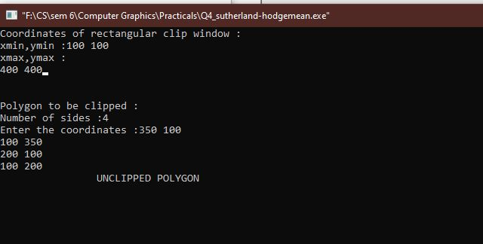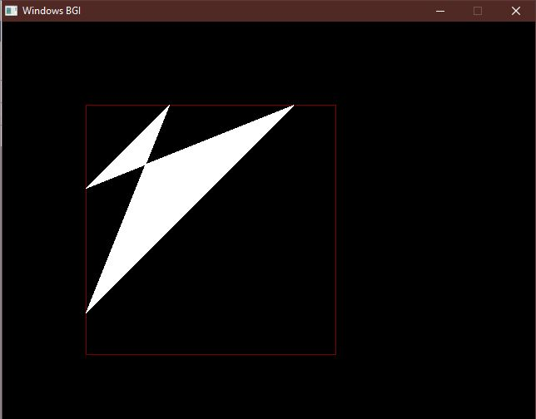

1. **Write a program to fill a polygon using Scan line fill algorithm.**

#include<iostream>

#include<graphics.h>

#include<math.h>

using namespace std;

const int WINDOW_HEIGHT = 1000;

typedef struct tdcPt

{

int x;

int y;

}dcPt;

typedef struct tEdge

{

int yUpper;

float xIntersect, dxPerScan;

struct tEdge *next;

}Edge;

// Vertices: Array of structures.

dcPt vertex[5] = {{200, 500}, {300, 250}, {270, 230}, {320, 200}, {360, 290}};

void insertEdge(Edge *list, Edge *edge){

Edge *p, *q = list;

p = q->next;

while (p != NULL)

{

if (edge->xIntersect < p->xIntersect)

p = NULL;

else

{

q = p;

p = p->next;

}

}

edge->next = q->next;

q->next = edge;

}

int yNext(int k, int cnt, dcPt *pts)

{

int j;

if ((k + 1) > (cnt - 1))

j = 0;

else

j = k + 1;while(pts[k].y == pts[j].y)

{

if ((j + 1) > (cnt - 1))

j = 0;

else

j++;

}

return (pts[j].y);

}

void makeEdgeRec(dcPt lower, dcPt upper, int yComp, Edge *edge, Edge*edges[])

{

edge->dxPerScan = (float) (upper.x - lower.x) / (upper.y - lower.y);

edge->xIntersect = lower.x;

if (upper.y < yComp)

edge->yUpper = upper.y - 1;

else

edge->yUpper = upper.y;

insertEdge(edges[lower.y], edge);

}

void buildEdgeList(int cnt, dcPt *pts, Edge *edges[])

{

Edge *edge;

dcPt v1, v2;int i, yPrev = pts[cnt - 2].y;

v1.x = pts[cnt - 1].x; v1.y = pts[cnt - 1].y;

for(int i = 0; i < cnt; i++)

{

v2 = pts[i];

if (v1.y != v2.y) // nonhorizontal line

{

edge = (Edge *) malloc (sizeof(Edge));

if (v1.y < v2.y) // upgoing edge

makeEdgeRec(v1, v2, yNext(i, cnt, pts), edge, edges);

else //down-going edge

makeEdgeRec(v2, v1 , yPrev, edge, edges);

}

yPrev = v1.y;

v1 = v2;

}

}

void buildActiveList(int scan, Edge *active, Edge *edges[])

{

Edge *p, *q;

p = edges[scan]->next;while (p)

{

q = p->next;

insertEdge(active, p);

p = q;

}

}

void fillScan(int scan, Edge *active)

{

Edge *p1, *p2 ;

int i;

p1 = active->next;

while (p1)

{

p2 = p1->next;

for(i = p1->xIntersect; i < p2->xIntersect; i++)

putpixel((int) i, scan, GREEN);

p1 = p2->next;

}

}

void deleteAfter(Edge *q)

{

Edge *p = q->next;q->next = p->next;

free(p);

}

void updateActiveList(int scan, Edge *active)

{

Edge *q = active, *p = active->next;

while (p)

{

if (scan >= p->yUpper)

{

p = p->next;

deleteAfter(q);

}

else

{

p->xIntersect = p->xIntersect + p->dxPerScan;

q = p;

p = p->next;

}

}

}

void resortActiveList(Edge *active)

{Edge *q, *p = active->next;

active->next = NULL;

while (p)

{

q = p->next;

insertEdge(active, p);

p = q;

}

}

void scanFill(int cnt, dcPt *pts)

{

Edge *edges[WINDOW_HEIGHT], *active;

int i, scan;

for (i = 0; i < WINDOW_HEIGHT; i++)

{

edges[i] = (Edge *) malloc (sizeof(Edge));;

edges[i]->next = NULL;

}

buildEdgeList(cnt, pts, edges);

active = (Edge *) malloc (sizeof(Edge));;

active->next = NULL;

for (scan = 0; scan < WINDOW_HEIGHT; scan++){

buildActiveList(scan, active, edges);

if (active->next)

{

fillScan(scan, active);

updateActiveList(scan, active) ;

resortActiveList(active);

}

}

free(edges[WINDOW_HEIGHT]);

free(active);

}

int main()

{

int gd = DETECT, gm;

initgraph(&gd, &gm, (char*)"");

float X = getmaxx(), Y = getmaxy();

float x_mid = X / 2;

float y_mid = Y / 2;

cleardevice();

scanFill(5, vertex);

getch();closegraph();

return 0;

}

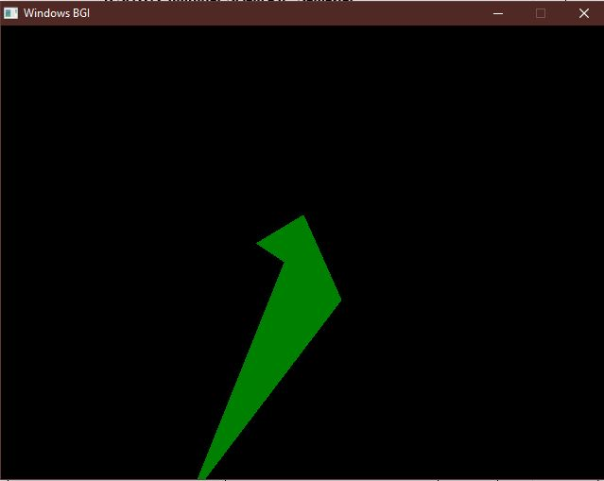

1. **Write a program to apply various 2D transformations on a 2D object (use homogenous Coordinates).**

#include<graphics.h>

#include<stdlib.h>

#include<stdio.h>

#include<iostream>

#include<conio.h>

#include<math.h>

using namespace std;

int mat[3][3];

void dda_line(int x1 , int y1 , int x2 , int y2 , int col){

int dx , dy , st;

dx = x2 - x1;

dy = y2 - y1;

float y , x , xinc , yinc;

int xmid , ymid;

xmid = getmaxx()/2;

ymid = getmaxy()/2;

if(abs(dx) > abs(dy)){

st = abs(dx);

}

else{

st = abs(dy);

}xinc = dx / st;

yinc = dy / st;

x = x1;

y = y1;

for(int i=0 ; i<st ; i++){

x += xinc;

y += yinc;

putpixel(ceil(x) + xmid , ymid - ceil(y),col);

} }

void rotate(){

int xmid , ymid;

xmid = getmaxx()/2;

ymid = getmaxy()/2;

line(xmid , 0 , xmid , getmaxy());

line(0 , ymid , getmaxx() , ymid);

int c[3][2] ,l , m, i , j , k;

int a[3][2]={{200,200},{200,100},{100,200}};

int t[2][2]={{0,1},{-1,0}};

for( i = 0 ; i < 3 ; i++){

for(j=0 ; j<2 ; j++){

c[i][j]=0;

}

}

dda_line(a[0][0],a[0][1],a[1][0],a[1][1],YELLOW);

dda_line(a[1][0],a[1][1],a[2][0],a[2][1],YELLOW);dda_line(a[2][0],a[2][1],a[0][0],a[0][1],YELLOW);

for ( i=0;i<3;i++){

for ( j=0;j<2;j++){

for ( k=0;k<2;k++){

c[i][j]=c[i][j]+(a[i][k]*t[k][j]);

}

}

}

dda_line(c[0][0],c[0][1],c[1][0],c[1][1],GREEN);

dda_line(c[1][0],c[1][1],c[2][0],c[2][1],GREEN);

dda_line(c[2][0],c[2][1],c[0][0],c[0][1],GREEN);

}

void reflection(){

int xmid , ymid;

xmid = getmaxx()/2;

ymid = getmaxy()/2;

line(xmid , 0 , xmid , getmaxy());

line(0 , ymid , getmaxx() , ymid);

int c[3][2] ,l , m, i , j , k;

int a[3][2]={{200,200},{200,100},{100,200}};

int t[2][2]={{0,-1},{-1,0}};

for( i = 0 ; i < 3 ; i++){

for(j=0 ; j<2 ; j++){

c[i][j]=0;

} }dda_line(a[0][0],a[0][1],a[1][0],a[1][1],YELLOW);

dda_line(a[1][0],a[1][1],a[2][0],a[2][1],YELLOW);

dda_line(a[2][0],a[2][1],a[0][0],a[0][1],YELLOW);

for ( i=0;i<3;i++){

for ( j=0;j<2;j++){

for ( k=0;k<2;k++){

c[i][j]=c[i][j]+(a[i][k]*t[k][j]);

} } }

dda_line(c[0][0],c[0][1],c[1][0],c[1][1],GREEN);

dda_line(c[1][0],c[1][1],c[2][0],c[2][1],GREEN);

dda_line(c[2][0],c[2][1],c[0][0],c[0][1],GREEN);

}

void scaling(){

int xmid , ymid;

xmid = getmaxx()/2;

ymid = getmaxy()/2;

line(xmid , 0 , xmid , getmaxy());

line(0 , ymid , getmaxx() , ymid);

int c[3][2] ,l , m, i , j , k;

int a[3][2]={{20,20},{20,10},{10,20}};

int t[2][2]={{5,0},{0,5}};

for( i = 0 ; i < 3 ; i++){

for(j=0 ; j<2 ; j++){

c[i][j]=0;} }

dda_line(a[0][0],a[0][1],a[1][0],a[1][1],YELLOW);

dda_line(a[1][0],a[1][1],a[2][0],a[2][1],YELLOW);

dda_line(a[2][0],a[2][1],a[0][0],a[0][1],YELLOW);

for ( i=0;i<3;i++){

for ( j=0;j<2;j++){

for ( k=0;k<2;k++){

c[i][j]=c[i][j]+(a[i][k]*t[k][j]);

} } }

dda_line(c[0][0],c[0][1],c[1][0],c[1][1],GREEN);

dda_line(c[1][0],c[1][1],c[2][0],c[2][1],GREEN);

dda_line(c[2][0],c[2][1],c[0][0],c[0][1],GREEN);

}

void multi(int a[3][3] , int b[3][3] ){

int i , j ,k;

int c[3][3];

for( i = 0 ; i < 3 ; i++){

for(j=0 ; j< 3 ; j++){

c[i][j]=0;

} }

for ( i=0;i<3;i++){

for ( j=0;j<3;j++){for ( k=0;k<3;k++){

c[i][j]=c[i][j]+(a[i][k]*b[k][j]);

} } }

for( i = 0 ; i < 3 ; i++){

for(j=0 ; j< 3 ; j++){

mat[i][j]=c[i][j];

} } }

void reflection_arbitrary(){

int xmid , ymid;

xmid = getmaxx()/2;

ymid = getmaxy()/2;

line(xmid , 0 , xmid , getmaxy());

line(0 , ymid , getmaxx() , ymid);

int a[3][3]={{200,200,1},{200,100,1},{100,200,1}};

int t[3][3]={{1,0,0},{0,1,0},{0,0,1}};

int r[3][3]={{-1,0,0},{0,-1,0},{0,0,1}};

int ref[3][3]={{1,0,0},{0,-1,0},{0,0,1}};

int rinv[3][3]={{-1,0,0},{0,-1,0},{0,0,1}};

int tinv[3][3]={{1,0,0},{0,1,0},{0,1,1}};

dda_line(a[0][0],a[0][1],a[1][0],a[1][1],YELLOW);

dda_line(a[1][0],a[1][1],a[2][0],a[2][1],YELLOW);

dda_line(a[2][0],a[2][1],a[0][0],a[0][1],YELLOW);multi(t,r);

multi(mat,ref);

multi(mat,rinv);

multi(mat,tinv);

multi(a,mat);

dda_line(mat[0][0],mat[0][1],mat[1][0],mat[1][1],GREEN);

dda_line(mat[1][0],mat[1][1],mat[2][0],mat[2][1],GREEN);

dda_line(mat[2][0],mat[2][1],mat[0][0],mat[0][1],GREEN);

}

void rotation_arbitrary(){

int xmid , ymid;

xmid = getmaxx()/2;

ymid = getmaxy()/2;

line(xmid , 0 , xmid , getmaxy());

line(0 , ymid , getmaxx() , ymid);

int c[3][3] , i , j , k;

int l[1][3]={{200,200,1}};

int a[3][3]={{200,200,1},{200,100,1},{100,200,1}};

int t[3][3]={{1,0,0},{0,1,0},{-133,-133,1}};

int r[3][3]={{-1,0,0},{0,-1,0},{0,0,1}};

int tinv[3][3]={{1,0,0},{0,1,0},{133,133,1}};

dda_line(a[0][0],a[0][1],a[1][0],a[1][1],YELLOW);

dda_line(a[1][0],a[1][1],a[2][0],a[2][1],YELLOW);

dda_line(a[2][0],a[2][1],a[0][0],a[0][1],YELLOW);

multi(t,r);

multi(mat,tinv);for( i = 0 ; i < 3 ; i++){

for(j=0 ; j<3 ; j++){

c[i][j]=0;

} }

for ( i=0;i<3;i++){

for ( j=0;j<3;j++){

for ( k=0;k<3;k++){

c[i][j]=c[i][j]+(a[i][k]*mat[k][j]);

} } }

dda_line(c[0][0],c[0][1],c[1][0],c[1][1],GREEN);

dda_line(c[1][0],c[1][1],c[2][0],c[2][1],GREEN);

dda_line(c[2][0],c[2][1],c[0][0],c[0][1],GREEN);

}

int main()

{

int gdriver = DETECT , gmode , errorcode;

initgraph(&gdriver, &gmode, "C:\\TURBOC3\\BGI");

int n , m;

cout<<" 1.Rotation \n 2.Reflection \n 3.Scaling \n 4.Reflection about anarbitrary axis \n";

cout<<" 5.Rotation about an arbitrary point\n";

cout<<"Enter your choice : ";

cin>>n;

switch(n){

case 1 : rotate();

break;

case 2 : reflection();

break;

case 3 : scaling();

break;

case 4 : reflection_arbitrary();

break;

case 5 : rotation_arbitrary();

break;

default : cout<<"Invalid Choice\n";

}

getch();

}

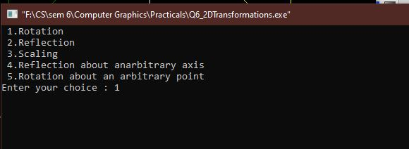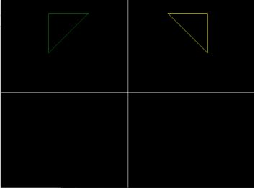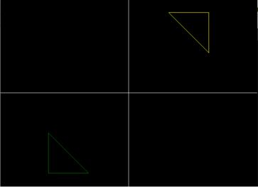

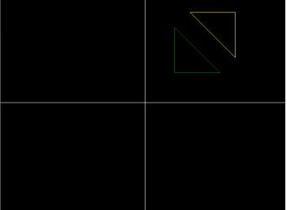

1. **Write a program to apply various 3D transformations on a 3D object and then apply parallel and perspective projection on it.**

#include <iostream>

#include <direct.h>

#include <stdio.h>

#include <math.h>

#include <conio.h>

#include <graphics.h>

#include <process.h>

using namespace std;

int gd = DETECT, gm;

double x1, x2, y2;

void draw_cube(double edge[20][3])

{

double y1;

initgraph(&gd, &gm, NULL);

int i;

clearviewport();

for (i = 0; i < 19; i++)

{

x1 = edge[i][0] + edge[i][2] * (cos(2.3562));

y1 = edge[i][1] - edge[i][2] * (sin(2.3562));

x2 = edge[i + 1][0] + edge[i + 1][2] * (cos(2.3562));

y2 = edge[i + 1][1] - edge[i + 1][2] * (sin(2.3562));

line(x1 + 320, 240 - y1, x2 + 320, 240 - y2);

}

line(320, 240, 320, 25);

line(320, 240, 550, 240);

line(320, 240, 150, 410);

getch();

closegraph();

}

void scale(double edge[20][3])

{

double a, b, c;

int i;

cout << "Enter The Scaling Factors: ";

cin >> a >> b >> c;

initgraph(&gd, &gm, NULL);

clearviewport();

for (i = 0; i < 20; i++)

{

edge[i][0] = edge[i][0] * a;

edge[i][1] = edge[i][1] * b;

edge[i][2] = edge[i][2] * c;

}

draw_cube(edge);

closegraph();

}

void translate(double edge[20][3])

{

int a, b, c;

int i;

cout << "Enter The Translation Factors: ";

cin >> a >> b >> c;

initgraph(&gd, &gm, NULL);

clearviewport();

for (i = 0; i < 20; i++)

{

edge[i][0] += a;

edge[i][0] += b;

edge[i][0] += c;

}

draw_cube(edge);

closegraph();

}

void rotate(double edge[20][3])

{

int ch;

int i;

double temp, theta, temp1;

cout << "-=[ Rotation About ]=-" << endl;

cout << "1:==> X-Axis " << endl;

cout << "2:==> Y-Axis" << endl;

cout << "3:==> Z-Axis " << endl;

cout << "Enter Your Choice: ";

cin >> ch;

switch (ch)

{

case 1:

cout << "Enter The Angle: ";

cin >> theta;

theta = (theta * 3.14) / 180;

for (i = 0; i < 20; i++)

{

edge[i][0] = edge[i][0];

temp = edge[i][1];

temp1 = edge[i][2];

edge[i][1] = temp * cos(theta) - temp1 * sin(theta);

edge[i][2] = temp * sin(theta) + temp1 * cos(theta);

}

draw_cube(edge);

break;

case 2:

cout << "Enter The Angle: ";

cin >> theta;

theta = (theta * 3.14) / 180;

for (i = 0; i < 20; i++)

{

edge[i][1] = edge[i][1];

temp = edge[i][0];

temp1 = edge[i][2];

edge[i][0] = temp * cos(theta) + temp1 * sin(theta);

edge[i][2] = -temp * sin(theta) + temp1 * cos(theta);

}

draw_cube(edge);

break;

case 3:

cout << "Enter The Angle: ";

cin >> theta;

theta = (theta * 3.14) / 180;

for (i = 0; i < 20; i++)

{

edge[i][2] = edge[i][2];

temp = edge[i][0];

temp1 = edge[i][1];

edge[i][0] = temp * cos(theta) - temp1 * sin(theta);

edge[i][1] = temp * sin(theta) + temp1 * cos(theta);

}

draw_cube(edge);

break;

}

}

void reflect(double edge[20][3])

{

int ch;

int i;

cout << "-=[ Reflection About ]=-" << endl;

cout << "1:==> X-Axis" << endl;

cout << "2:==> Y-Axis " << endl;

cout << "3:==> Z-Axis " << endl;

cout << "Enter Your Choice: ";

cin >> ch;

switch (ch)

{

case 1:

for (i = 0; i < 20; i++)

{

edge[i][0] = edge[i][0];

edge[i][1] = -edge[i][1];

edge[i][2] = -edge[i][2];

}

draw_cube(edge);

break;

case 2:

for (i = 0; i < 20; i++)

{

edge[i][1] = edge[i][1];

edge[i][0] = -edge[i][0];

edge[i][2] = -edge[i][2];

}

draw_cube(edge);

break;

case 3:

for (i = 0; i < 20; i++)

{

edge[i][2] = edge[i][2];

edge[i][0] = -edge[i][0];

edge[i][1] = -edge[i][1];

}

draw_cube(edge);

break;

}

}

void perspect(double edge[20][3])

{

int ch;

int i;

double p, q, r;

cout << "-=[ Perspective Projection About ]=-" << endl;

cout << "1:==> X-Axis " << endl;

cout << "2:==> Y-Axis " << endl;

cout << "3:==> Z-Axis" << endl;

cout << "Enter Your Choice := ";

cin >> ch;

switch (ch)

{

case 1:

cout << " Enter P := ";

cin >> p;

for (i = 0; i < 20; i++)

{

edge[i][0] = edge[i][0] / (p * edge[i][0] + 1);

edge[i][1] = edge[i][1] / (p * edge[i][0] + 1);

edge[i][2] = edge[i][2] / (p * edge[i][0] + 1);

}

draw_cube(edge);

break;

case 2:

cout << " Enter Q := ";

cin >> q;

for (i = 0; i < 20; i++)

{

edge[i][1] = edge[i][1] / (edge[i][1] * q + 1);

edge[i][0] = edge[i][0] / (edge[i][1] * q + 1);

edge[i][2] = edge[i][2] / (edge[i][1] * q + 1);

}

draw_cube(edge);

break;

case 3:

cout << " Enter R := ";

cin >> r;

for (i = 0; i < 20; i++)

{

edge[i][2] = edge[i][2] / (edge[i][2] * r + 1);

edge[i][0] = edge[i][0] / (edge[i][2] * r + 1);

edge[i][1] = edge[i][1] / (edge[i][2] * r + 1);

}

draw_cube(edge);

break;

}

closegraph();

}

int main()

{

int choice;

double edge[20][3] = {

100, 0, 0,

100, 100, 0,

0, 100, 0,

0, 100, 100,

0, 0, 100,

0, 0, 0,

100, 0, 0,

100, 0, 100,

100, 75, 100,

75, 100, 100,

100, 100, 75,

100, 100, 0,

100, 100, 75,

100, 75, 100,

75, 100, 100,

0, 100, 100,

0, 100, 0,

0, 0, 0,

0, 0, 100,

100, 0, 100};

while (1)

{

cout << "1:==> Draw Cube " << endl;

cout << "2:==> Scaling " << endl;

cout << "3:==> Rotation " << endl;

cout << "4:==> Reflection " << endl;

cout << "5:==> Translation " << endl;

cout << "6:==> Perspective Projection " << endl;

cout << "7:==> Exit " << endl;

cout << "Enter Your Choice := ";

cin >> choice;

switch (choice)

{

case 1:

draw_cube(edge);

break;

case 2:

scale(edge);

break;

case 3:

rotate(edge);

break;

case 4:

reflect(edge);

break;

case 5:

translate(edge);

break;

case 6:

perspect(edge);

break;

case 7:

exit(0);

default:

cout << "\nPress A Valid Key...!!! ";

getch();

break;

}

closegraph();

}

return 0;

}

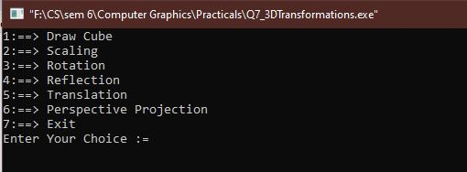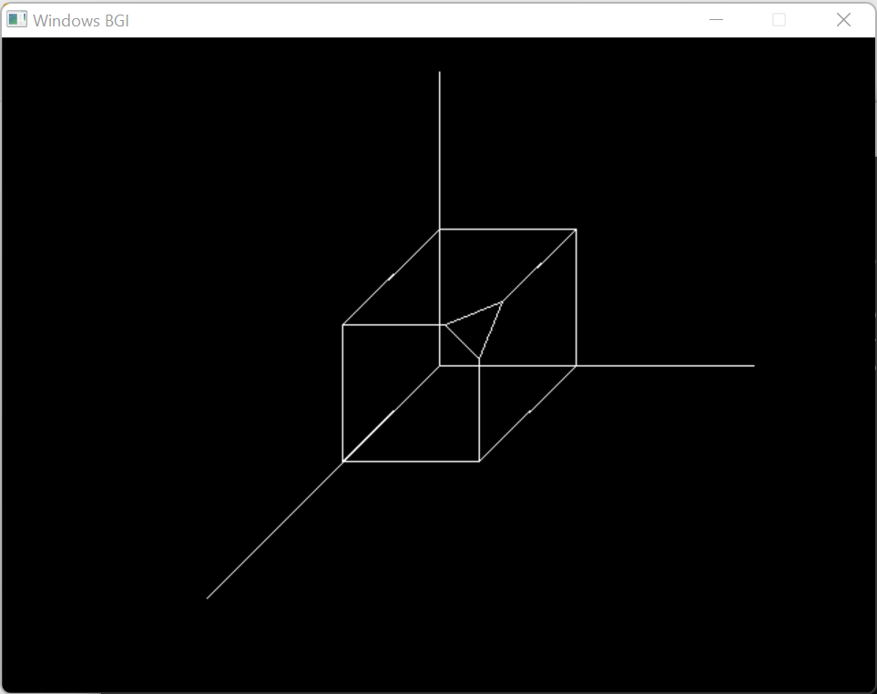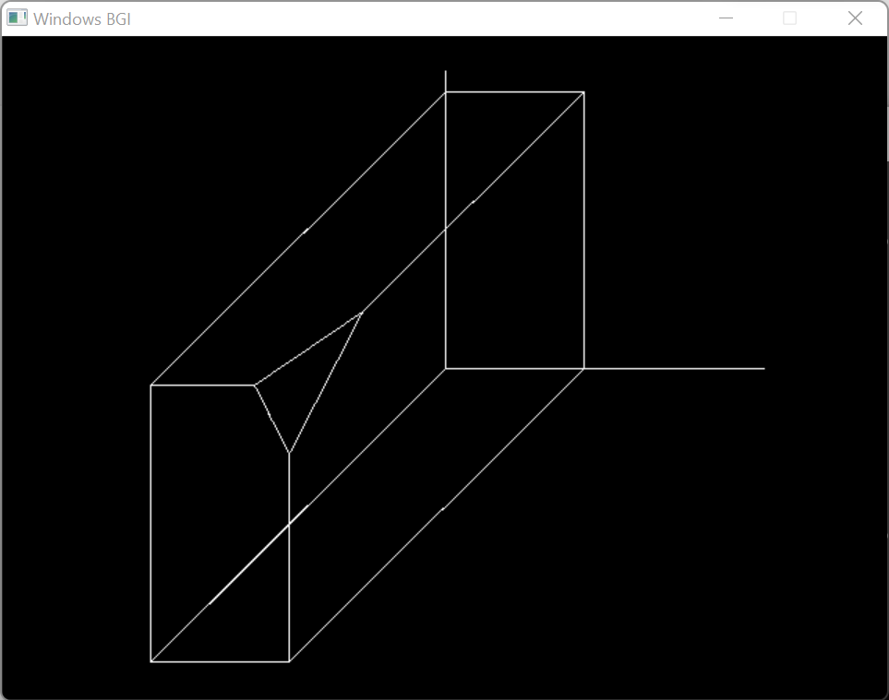

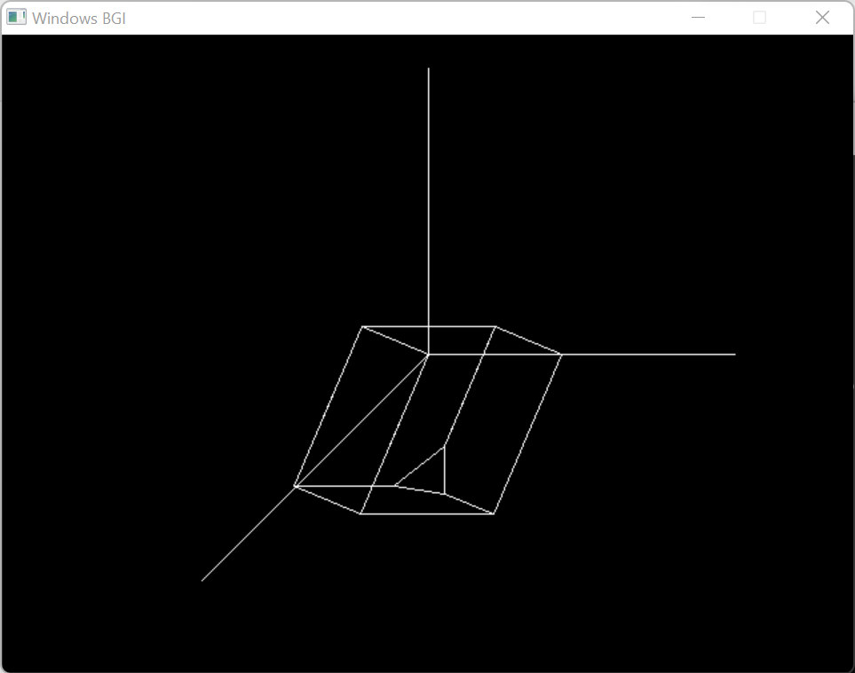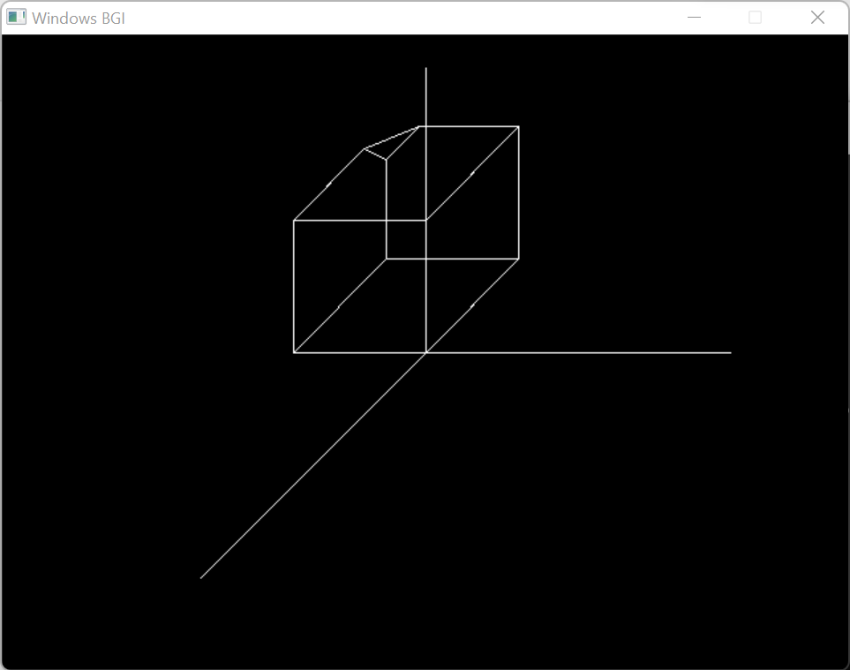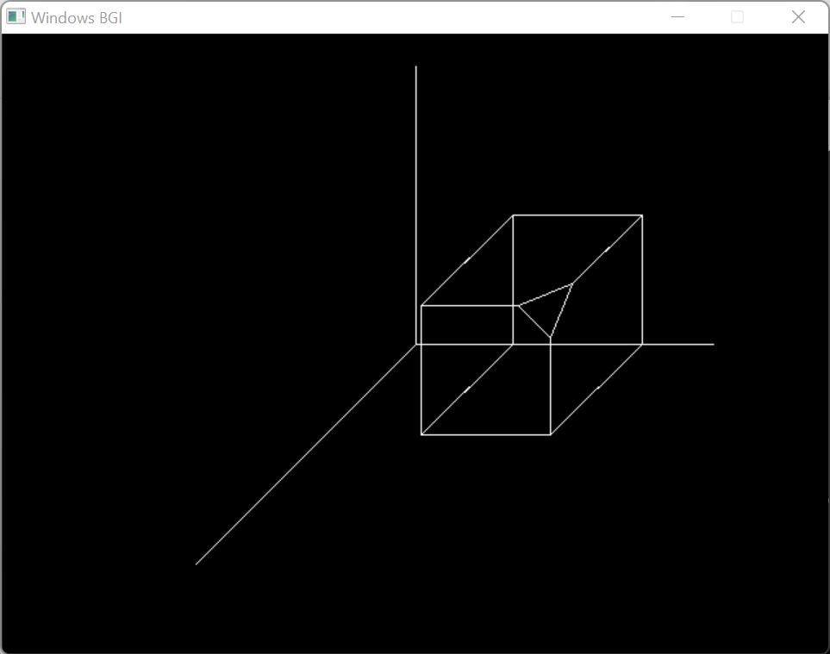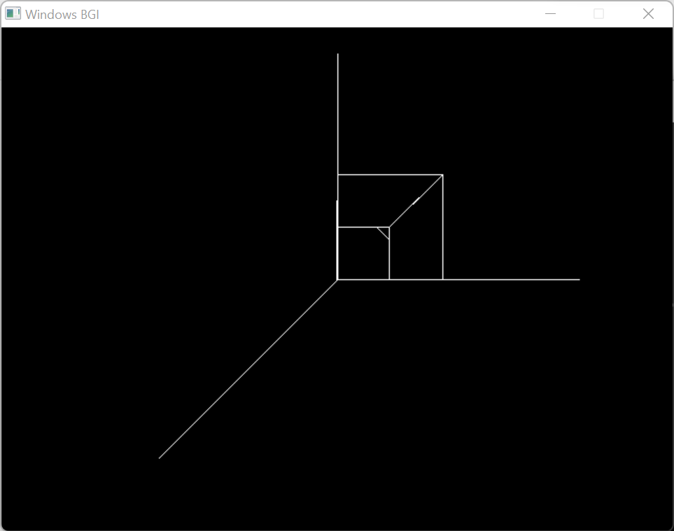

**8. Write a program to draw Hermite /Bezier curve.**

**Hermite Curve**

#include <conio.h>

#include <graphics.h>

#include <iostream>

#include <math.h>

#include <stdio.h>

#include <stdlib.h>

using namespace std;

struct point

{

int x, y;

};

void hermite(point p1, point p4, double r1, double r4)

{

float x, y, t;

for (t = 0.0; t <= 1.0; t += 0.00005)

{

x = (2 * pow(t, 3) - 3 * pow(t, 2) + 1) * p1.x +

(-2 * pow(t, 3) + 3 * pow(t, 2)) * p4.x +

(pow(t, 3) - 2 * pow(t, 2) + t) * r1 +

(pow(t, 3) - pow(t, 2)) * r4;

y = (2 * pow(t, 3) - 3 * pow(t, 2) + 1) * p1.y +

(-2 * pow(t, 3) + 3 * pow(t, 2)) * p4.y +

(pow(t, 3) - 2 * pow(t, 2) + 1) * r1 +

(pow(t, 3) - pow(t, 2)) * r4;

putpixel(x, y, WHITE);

}

circle(p1.x, p1.y, 3);

circle(p4.x, p4.y, 3);

}

int main()

{

point p1, p4;

double r1, r4;

int gd = DETECT, gm;

initgraph(&gd, &gm, "..\\BGI");

cout << "Enter Point 1 (x, y): ";

cin >> p1.x >> p1.y;

cout << "Enter Point 2 (x, y): ";

cin >> p4.x >> p4.y;

cout << "Enter Tangent at Point 1: ";

cin >> r1;

cout << "Enter Tangent at Point 4: ";

cin >> r4;

hermite(p1, p4, r1, r4);

getch();

closegraph();

}

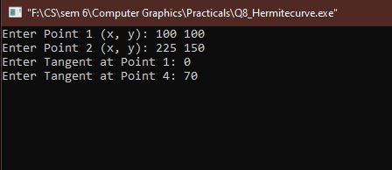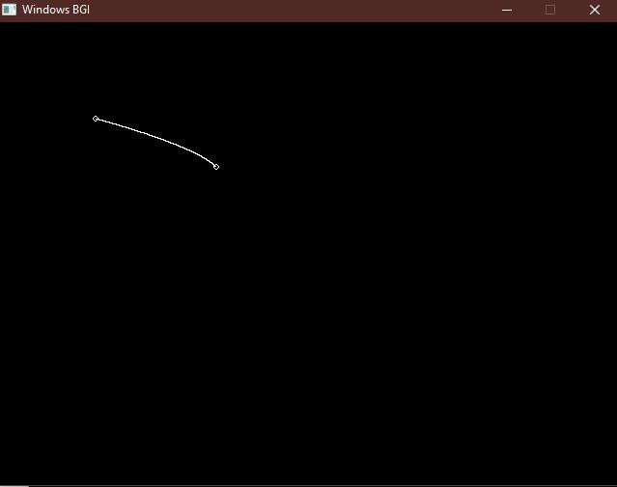

**Bezier Curve**

#include<graphics.h>

#include<math.h>

#include<conio.h>

#include<stdio.h>

int main()

{

int x[4],y[4],i;

double put_x,put_y,t;

int gr=DETECT,gm;

initgraph(&gr,&gm,NULL);

printf("\n****** Bezier Curve ***********");

printf("\n Please enter x and y coordinates ");

for(i=0;i<4;i++)

{

scanf("%d%d",&x[i],&y[i]);

putpixel(x[i],y[i],3); // Control Points

}

for(t=0.0;t<=1.0;t=t+0.001) // t always lies between 0 and 1

{

put_x = pow(1-t,3)*x[0] + 3*t*pow(1-t,2)*x[1] + 3*t*t*(1-t)*x[2] + pow(t,3)*x[3]; // Formula to draw curve

put_y = pow(1-t,3)*y[0] + 3*t*pow(1-t,2)*y[1] + 3*t*t*(1-t)*y[2] + pow(t,3)*y[3];

putpixel(put_x,put_y, WHITE); // putting pixel

}

getch();

closegraph();

return 0;

}

